

**CAPSTONE PROJECT REPORT**

**Report 4 – Software Design Document**

– Ho Chi Minh, January 2022 –

**Table of Contents**

IV. Software Design Document 9

1. Overall Description 9

1.1 Assumptions 9

1.2 Design Constraints 9

2. System Architecture Design 10

2.1 Overall Architecture 10

2.2. Backend Architecture 11

2.3. Web Application Architecture 11

2.4. Mobile Application Architecture 12

2.5 Package Diagram 13

2.3.1. Backend Package Diagram 13

2.3.2. Web Application Package Diagram 14

2.3.3. Mobile Application Package Diagram 16

3. System Detailed Design 19

3.1 Sequence Diagrams 19

3.1.1. Account management 19

● Create account 19

● Update account 19

● Disable account 20

● View account list 20

● Reset password 21

3.1.2. Subject management 21

● Create subject 21

● Update subject 22

● Disable subject 22

● View subject list 23

3.1.3. Semester management 23

● Create semester 23

● Update semester 24

● Disable semester 24

● View semester list 25

● Add subject to semester 25

● Remove subject from semester 26

3.1.4. Tool management 26

● Create tool 26

● Update tool 27

● Disable tool 27

● View tool list 28

● Add tool to subject 28

● Remove tool from subject 29

3.1.5. Room management 29

● Create room 29

● Update room 30

● Disable room 30

● View room list 31

3.1.6. Manage shift 31

● Create shift 31

● Update shift 32

● Delete shift 32

● Lock shift 33

● Start staffing 33

● View shift list 34

● View shift detail 34

3.1.7. Manage examinee 35

● Import examinees 35

● Remove examinee from semester’s subject 36

● View subject assignments list 36

● View subject assignments detail 37

3.1.8. Manage exam room 37

● Create exam room 37

● Update exam room 38

● Remove exam room 38

● View exam shift list 39

● Create attendance 39

● Delete attendance 40

● Export attendance 40

● Export locked shift 41

● Assign staff 41

● Auto assign staff 42

3.1.9. Login 42

3.1.10. Logout 43

3.1.11. Change password 43

3.1.12. View profile 44

3.1.13. Update profile 44

3.1.14. View notification list 45

3.1.15. View report list 45

3.1.16. View report detail 46

3.1.17. Resolve report 47

3.2 Activity Diagrams 48

3.2.1. Update attendance 48

3.2.2. View attendances of exam room 49

3.2.3. Create report 50

3.2.4. View assigned exam room 51

3.2.5. View assigned exam room report list 52

3.2.6. Update report 53

3.2.7. View own exam schedule 54

3.2.8. Check attendance 55

3.3 State Diagrams 56

3.3.1. Shift 56

3.3.2. Exam room 56

3.3.3. Attendance 57

3.4 Class Diagrams 58

4. Class Specifications 59

4.1. Account class 59

4.2. Role class 59

4.3. Room class 60

4.4. Semester class 60

4.5. Shift class 61

4.6. Subject class 61

4.7. Notification class 62

4.8. Tool class 62

4.9. Subject Semester class 62

4.10. Subject Examinee class 63

4.11. Attendance class 63

4.12. Exam room class 64

4.13. Report class 65

4.14. Attempt class 65

5. Data & Database Design 67

5.1. Database Design 67

5.2. Data Dictionary 68

5.2.1. App user table 68

5.2.2. App user role table 69

5.2.3. Attempt table 69

5.2.4. Attendance table 70

5.2.5. Exam room table 70

5.2.6. Notification table 71

5.2.7. Report table 72

5.2.8. Room table 73

5.2.9. Semester table 74

5.2.10. Shift table 74

5.2.11. Subject table 75

5.2.12. Subject examinee table 75

5.2.13. Subject semester table 76

5.2.14. Subject tool table 76

5.2.15. Tool table 77

**Table of Figures**

Figure 1. Overall Architecture 10

Figure 2. Backend Architecture 11

Figure 3. Web Application Architecture 11

Figure 4. Mobile Application Architecture 12

Figure 5. Backend Package Diagram 13

Figure 6. Web Application Package Diagram 15

Figure 7. Web Application Package Diagram 17

Figure 8. <Sequence Diagram> Create account 19

Figure 9. <Sequence Diagram> Update account 19

Figure 10. <Sequence Diagram> Disable account 20

Figure 11. <Sequence Diagram> View account list 20

Figure 12. <Sequence Diagram> Reset password 21

Figure 13. <Sequence Diagram> Create subject 21

Figure 14. <Sequence Diagram> Update subject 22

Figure 15. <Sequence Diagram> Disable subject 22

Figure 16. <Sequence Diagram> View subject list 23

Figure 17. <Sequence Diagram> Create semester 23

Figure 18. <Sequence Diagram> Update semester 24

Figure 19. <Sequence Diagram> Disable semester 24

Figure 20. <Sequence Diagram> View semester list 25

Figure 21. <Sequence Diagram> Add subject to semester 25

Figure 22. <Sequence Diagram> Remove subject from semester 26

Figure 23. <Sequence Diagram> Create tool 26

Figure 24. <Sequence Diagram> Update tool 27

Figure 25. <Sequence Diagram> Disable tool 27

Figure 26. <Sequence Diagram> View tool list 28

Figure 27. <Sequence Diagram> Add tool to subject 28

Figure 28. <Sequence Diagram> Remove tool from subject 29

Figure 29. <Sequence Diagram> Create room 29

Figure 30. <Sequence Diagram> Update room 30

Figure 31. <Sequence Diagram> Disable room 30

Figure 32. <Sequence Diagram> View room list 31

Figure 33. <Sequence Diagram> Create shift 31

Figure 34. <Sequence Diagram> Update shift 32

Figure 35. <Sequence Diagram> Delete shift 32

Figure 36. <Sequence Diagram> Lock shift 33

Figure 37. <Sequence Diagram> Start staffing 33

Figure 38. <Sequence Diagram> View shift list 34

Figure 39. <Sequence Diagram> View shift detail 34

Figure 40. <Sequence Diagram> Import examinees 35

Figure 41. <Sequence Diagram> Remove examinee from semester's subject 36

Figure 42. <Sequence Diagram> View subject assignment list 36

Figure 43. <Sequence Diagram> View subject assignments detail 37

Figure 44. <Sequence Diagram> Create exam room 37

Figure 45. <Sequence Diagram> Update exam room 38

Figure 46. <Sequence Diagram> Remove exam room 38

Figure 47. <Sequence Diagram> View exam shift list 39

Figure 48. <Sequence Diagram> Create attendance 39

Figure 49. <Sequence Diagram> Delete attendance 40

Figure 50. <Sequence Diagram> Export attendance 40

Figure 51. <Sequence Diagram> Export locked shift 41

Figure 52. <Sequence Diagram> Assign staff 41

Figure 53. <Sequence Diagram> Auto assign staff 42

Figure 54. <Sequence Diagram> Login 42

Figure 55. <Sequence Diagram> Logout 43

Figure 56. <Sequence Diagram> Change password 43

Figure 57. <Sequence Diagram> View profile 44

Figure 58. <Sequence Diagram> Update profile 44

Figure 59. <Sequence Diagram> View notification list 45

Figure 60. <Sequence Diagram> View report list 45

Figure 61. <Sequence Diagram> View report detail 46

Figure 62. <Sequence Diagram> Resolve report 47

Figure 63. <Activity Diagram> Update attendance 48

Figure 64. <Activity Diagram> View attendances of exam room 49

Figure 65. <Activity Diagram> Create report 50

Figure 66. <Activity Diagram> View assigned exam room 51

Figure 67. <Activity Diagram> View assigned exam room report list 52

Figure 68. <Activity Diagram> Update report 53

Figure 69. <Activity Diagram> View own exam schedule 54

Figure 70. <Activity Diagram> Check attendance 55

Figure 71. <State Diagram> Shift 56

Figure 72. <State Diagram> Exam room 56

Figure 73. <State Diagram> Attendance 57

Figure 74. Class Diagram 58

Figure 75. Database design 67

**List of Tables**

Table 1. Backend Package Diagram - Code Package 13

Table 2. Web Application Package Diagram - Code Package 16

Table 3. Mobile Application Package Diagram - Code Package 18

Table 4. <Class Specification> Account class 59

Table 5. <Class Specification> Role class 59

Table 6. <Class Specification> Room class 60

Table 7. <Class Specification> Semester class 60

Table 8. <Class Specification> Shift class 61

Table 9. <Class Specification> Subject class 61

Table 10. <Class Specification> Notification class 62

Table 11. <Class Specification> Tool class 62

Table 12. <Class Specification> Subject Semester class 62

Table 13. <Class Specification> Subject Examinee Class 63

Table 14. <Class Specification> Attendance class 63

Table 15. <Class Specification> Exam room class 64

Table 16. <Class Specification> Report class 65

Table 17. <Class Specification> Attempt class 65

Table 18. <Database Design> App user table 68

Table 19. <Database Design> App user role table 69

Table 20. <Database Design> Attempt table 69

Table 21. <Database Design> Attendance table 70

Table 22. <Database Design> Exam room table 70

Table 23. <Database Design> Notification table 71

Table 24. <Database Design> Report table 72

Table 25. <Database Design> Room table 73

Table 26. <Database Design> Semester table 74

Table 27. <Database Design> Shift table 74

Table 28. <Database Design> Subject table 75

Table 29. <Database Design> Subject examinee table 75

Table 30. <Database Design> Subject semester table 76

Table 31. <Database Design> Subject tool table 76

Table 32. <Database Design> Tool table 77

# IV. Software Design Document

## 1. Overall Description

### 1.1 Assumptions

VaLua is designed based on the following assumptions:

* **Hardware:**
  + Camera resolution: 720p/30fps or higher, and a viewing angle of 60°.
  + Central Processing Unit (CPU): Intel Core i5 8th Generation processor or higher.
  + RAM – 8GB or higher
  + Graphic Processing Unit (GPU): NVIDIA GeForce GTX 1050ti or higher.
* **Software:**
  + Chrome (version 87 or higher)
  + IE (version 11 or higher) or any browser that supports HTML5 and CSS3
  + NodeJS 14.16.1
  + Java 11
  + Flutter 2.8
  + PostgreSQL version 13
* **Operating systems:**
  + Android version 6.0 (Marshmallow) or higher
  + Windows 10 (Professional edition version 1909 or higher)
* **End-user characteristics:**
  + **Manager:** using the system to manage accounts, rooms, subjects with their tools, semesters and their subjects.
  + **Shift Manager:** using the system to manage examinees’ assignments, shifts with exam rooms and reports about violations or incidents that may occur during the exams.
  + **Staff:** using the system to register shifts, view proctoring schedules, manage attendances checking, create reports and finish exams they supervise.
  + **Examinee:** using the system to view their exam schedules and check their attendances.

### 1.2 Design Constraints

* **Interoperability requirements:**
  + Data transmission over the internet
* **Performance and reliability requirements:**
  + Processing examinee images to check attendance should handle timeout and must provide results within 10 seconds.
  + Sending emails must be restricted to 100 emails per task, 2 minutes between tasks.
  + Using multitasking, multithreading to handle concurrent tasks.

## 2. System Architecture Design

### 2.1 Overall Architecture

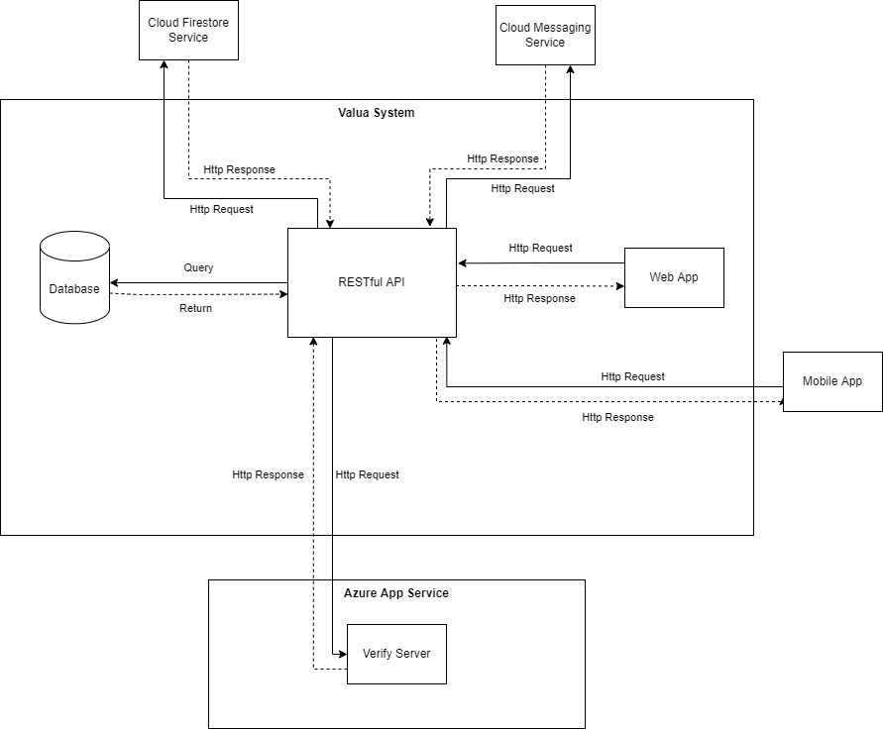

Figure . Overall Architecture

### 2.2. Backend Architecture

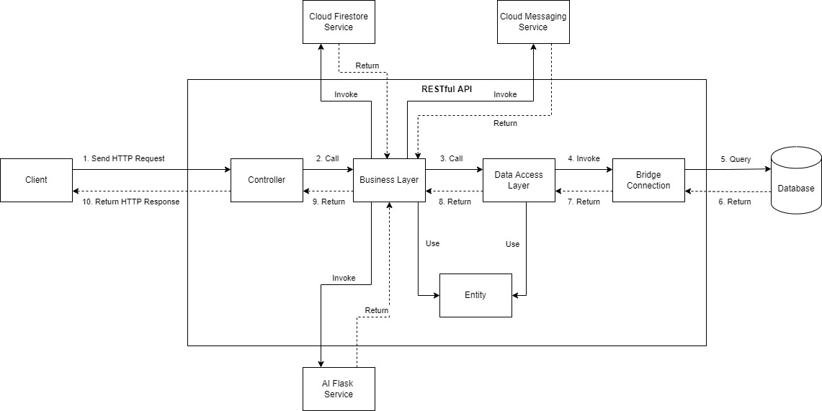

Figure . Backend Architecture

### 2.3. Web Application Architecture

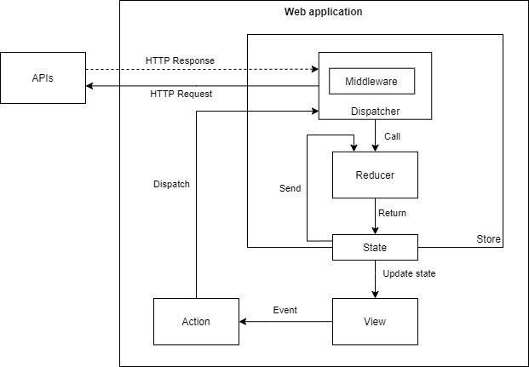

Figure . Web Application Architecture

### 2.4. Mobile Application Architecture

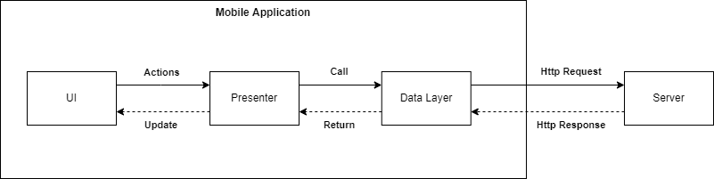

Figure . Mobile Application Architecture

### 2.5 Package Diagram

#### 2.3.1. Backend Package Diagram

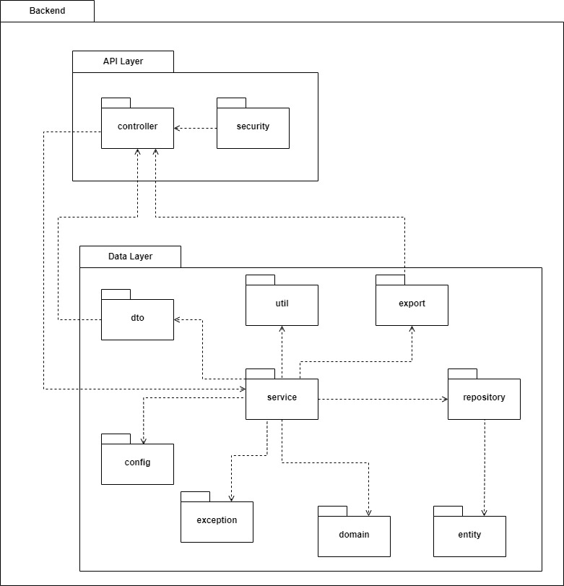

Figure . Backend Package Diagram

Table . Backend Package Diagram - Code Package

|  |  |  |
| --- | --- | --- |
| **No** | **Package** | **Description** |
| 1 | controller | The package contains controller classes, responsible for handling the HTTP requests and returning responses with values. |
| 2 | config | The package contains configuration classes and constant classes used in the backend. |
| 3 | dto | The package contains classes used for data binding and mapping response. |
| 4 | service | The package contains service classes used for handling business logic. |
| 5 | repository | The package contains repository classes for handling data access queries. |
| 6 | entity | The package contains entity classes for data mapping from the database tables. |
| 7 | exception | The package contains exception handlers and custom exceptions defined in the system. |
| 8 | export | The package contains view resolver and view models classes for excel, csv and pdf file exports. |
| 9 | utils | The package contains utility methods for common uses. |
| 10 | security | The package contains Json Web Token provider class, user principal class and Oauth2 service classes. |
| 11 | domain | The package contains custom pageable classes for pagination, custom quartz scheduler service and executor classes, custom QR code service class. |

#### 2.3.2. Web Application Package Diagram

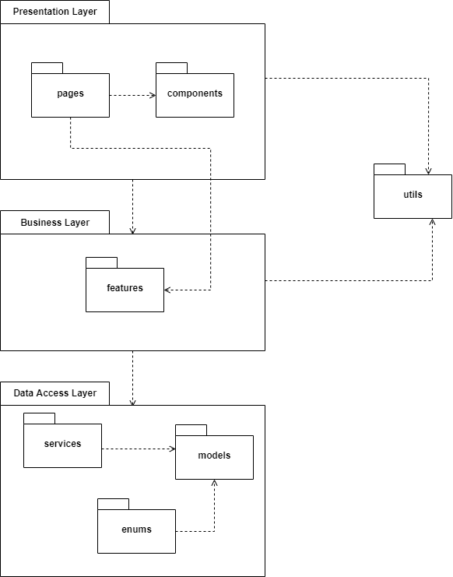

Figure . Web Application Package Diagram

Table . Web Application Package Diagram - Code Package

|  |  |  |
| --- | --- | --- |
| **No** | **Package** | **Description** |
| 1 | pages | The package contains pages, responsible for grouping components together |
| 2 | components | The package contains components for specific use in a specific page. |
| 3 | utils | The package contains utility methods for common use. |
| 4 | features | The package contains classes used for handling business logic, managing state. |
| 5 | services | The package contains classes responsible for handling data between REST APIs and web application. |
| 6 | models | The package contains model classes for data binding. |
| 7 | enums | The package contains all the enums for data mapping and components |

#### 2.3.3. Mobile Application Package Diagram

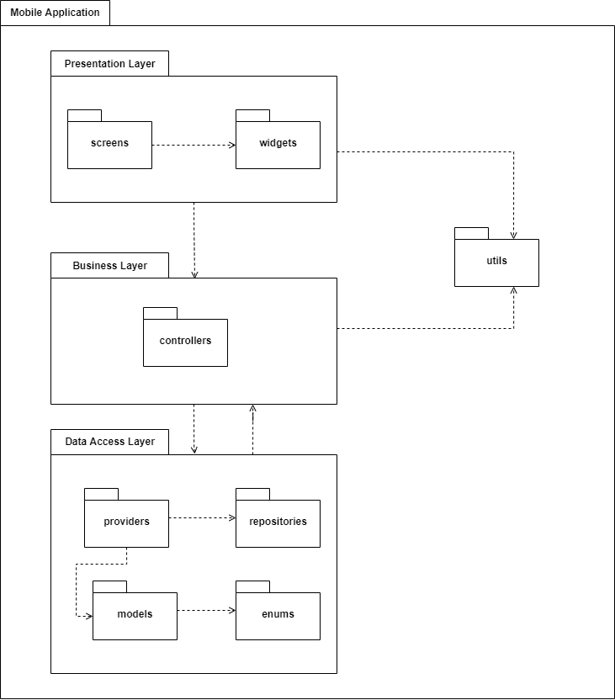

Figure . Web Application Package Diagram

Table . Mobile Application Package Diagram - Code Package

|  |  |  |
| --- | --- | --- |
| **No** | **Package** | **Description** |
| 1 | screens | The package contains screens, responsible for grouping widgets together |
| 2 | widgets | The package contains widgets for specific use in a specific screen. |
| 3 | utils | The package contains utility methods for common use. |
| 4 | controllers | The package contains controller classes used for handling business logic. |
| 5 | providers | The package contains classes responsible for handling data between REST APIs and mobile application. |
| 6 | repositories | The package contains all repository classes for the data access layer. |
| 7 | models | The package contains model classes for data binding. |
| 8 | enums | The package contains all the enums for data mapping and widgets |

## 3. System Detailed Design

### 3.1 Sequence Diagrams

#### 3.1.1. Account management

##### Create account

Figure . <Sequence Diagram> Create account

##### Update account

Figure . <Sequence Diagram> Update account

##### Disable account

Figure . <Sequence Diagram> Disable account

##### View account list

Figure . <Sequence Diagram> View account list

##### Reset password

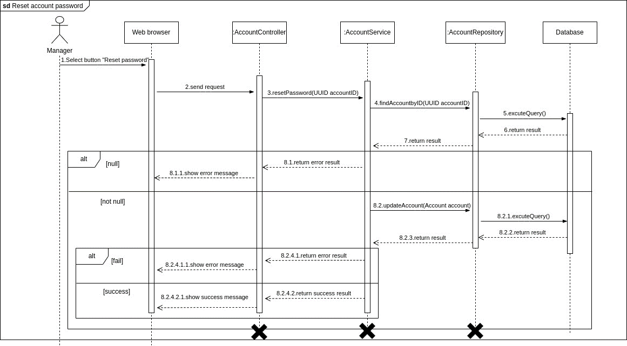

Figure . <Sequence Diagram> Reset password

#### 3.1.2. Subject management

##### Create subject

Figure . <Sequence Diagram> Create subject

##### Update subject

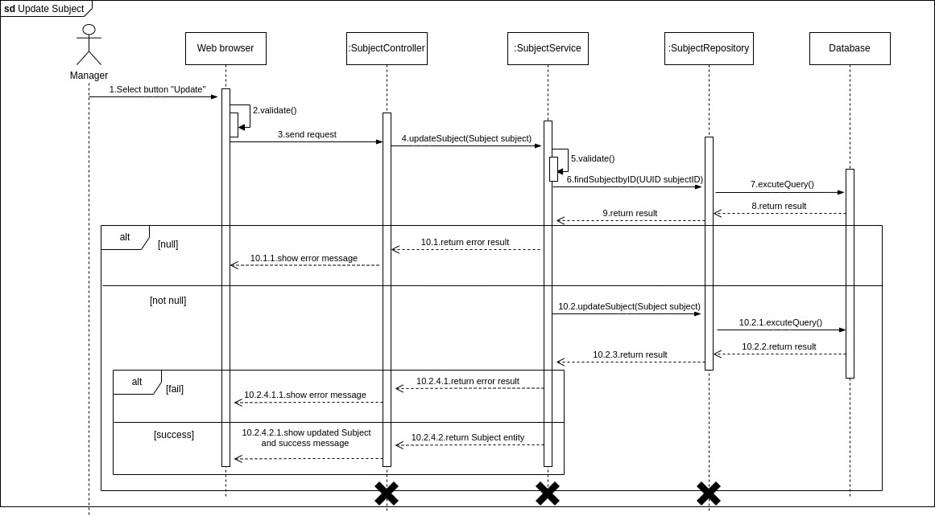

Figure . <Sequence Diagram> Update subject

##### Disable subject

Figure . <Sequence Diagram> Disable subject

##### View subject list

Figure . <Sequence Diagram> View subject list

#### 3.1.3. Semester management

##### Create semester

Figure . <Sequence Diagram> Create semester

##### Update semester

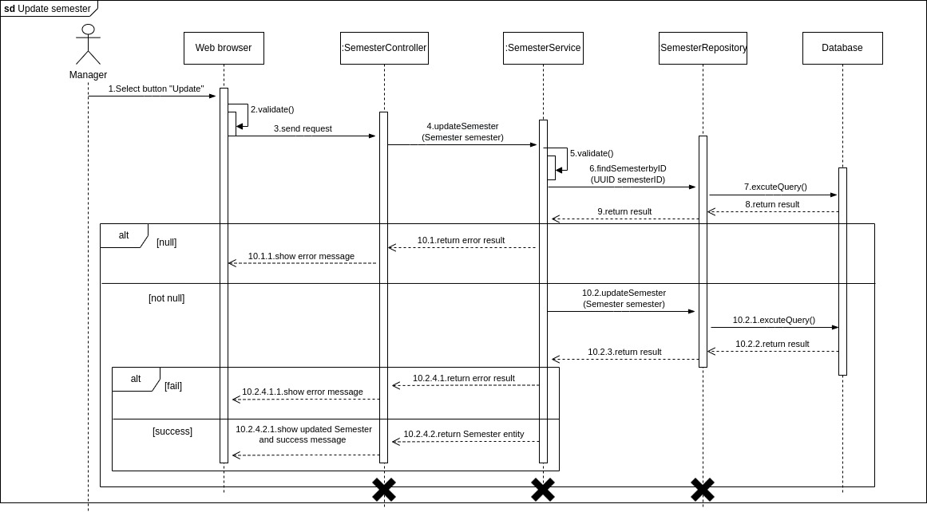

Figure . <Sequence Diagram> Update semester

##### Disable semester

Figure . <Sequence Diagram> Disable semester

##### View semester list

Figure . <Sequence Diagram> View semester list

##### Add subject to semester

Figure . <Sequence Diagram> Add subject to semester

##### Remove subject from semester

Figure . <Sequence Diagram> Remove subject from semester

#### 3.1.4. Tool management

##### Create tool

Figure . <Sequence Diagram> Create tool

##### Update tool

Figure . <Sequence Diagram> Update tool

##### Disable tool

Figure . <Sequence Diagram> Disable tool

##### View tool list

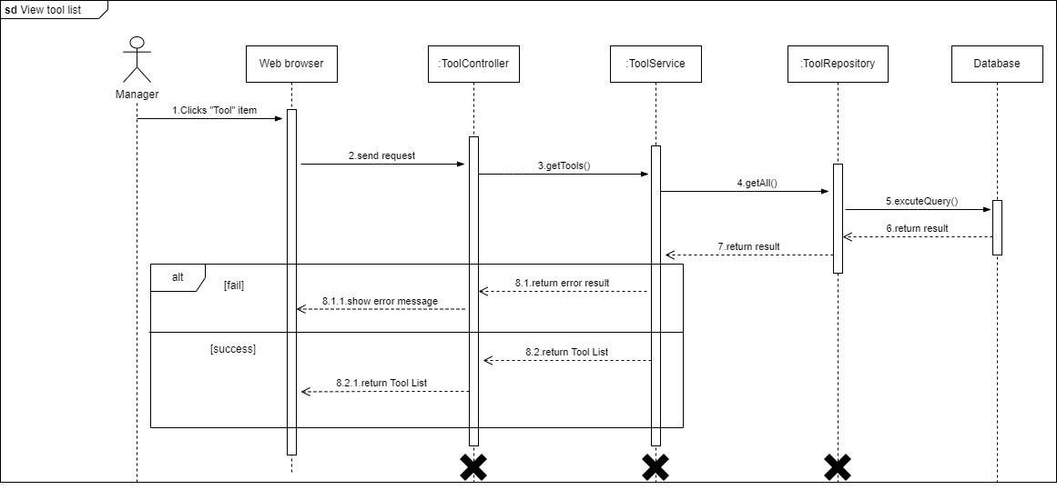

Figure . <Sequence Diagram> View tool list

##### Add tool to subject

Figure . <Sequence Diagram> Add tool to subject

##### Remove tool from subject

Figure . <Sequence Diagram> Remove tool from subject

#### 3.1.5. Room management

##### Create room

Figure . <Sequence Diagram> Create room

##### Update room

Figure . <Sequence Diagram> Update room

##### Disable room

Figure . <Sequence Diagram> Disable room

##### View room list

Figure . <Sequence Diagram> View room list

#### 3.1.6. Manage shift

##### Create shift

Figure . <Sequence Diagram> Create shift

##### Update shift

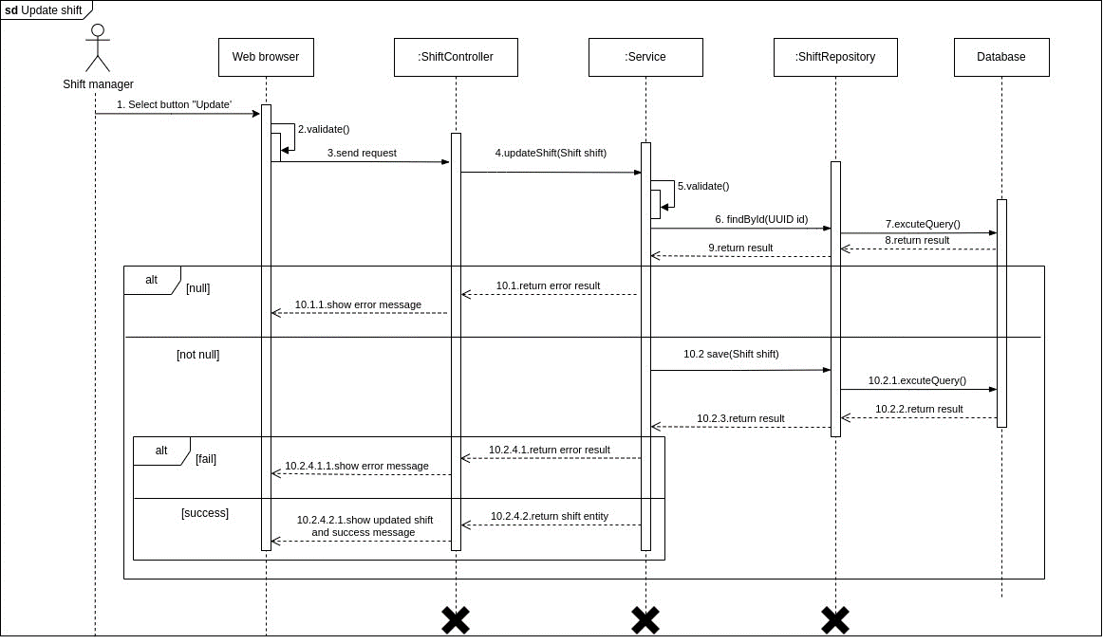

Figure . <Sequence Diagram> Update shift

##### Delete shift

Figure . <Sequence Diagram> Delete shift

##### Lock shift

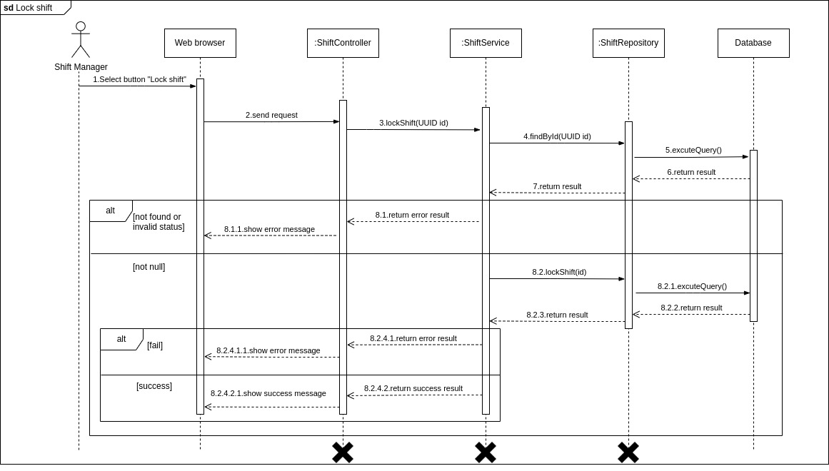

Figure . <Sequence Diagram> Lock shift

##### Start staffing

Figure . <Sequence Diagram> Start staffing

##### View shift list

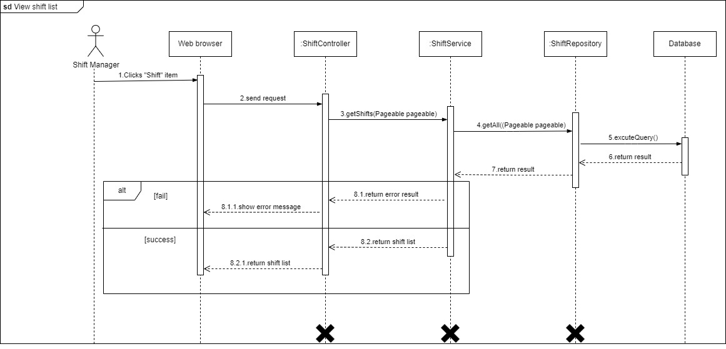

Figure . <Sequence Diagram> View shift list

##### View shift detail

Figure 39. <Sequence Diagram> View shift detail

#### 3.1.7. Manage examinee

##### Import examinees

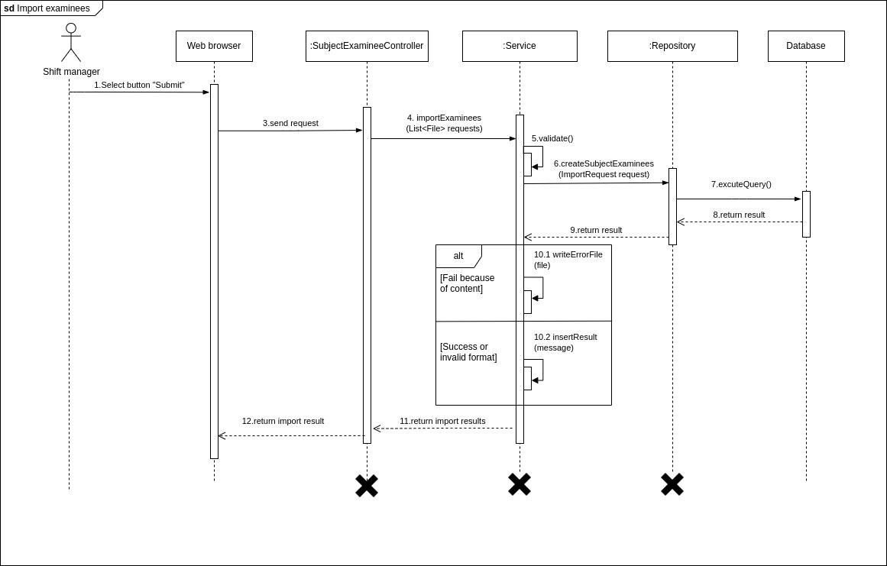

Figure . <Sequence Diagram> Import examinees

##### Remove examinee from semester’s subject

Figure . <Sequence Diagram> Remove examinee from semester's subject

##### View subject assignments list

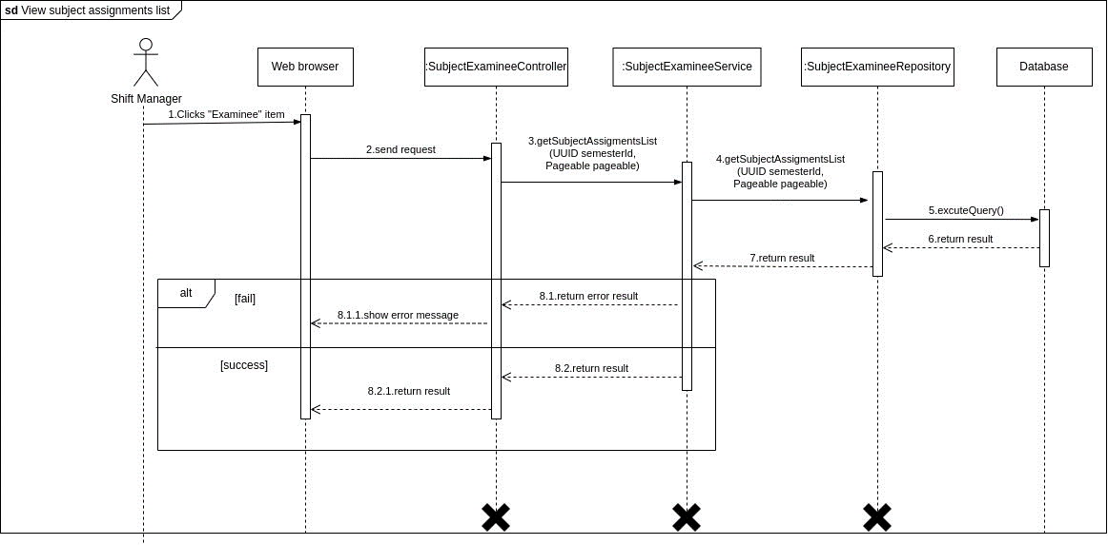

Figure . <Sequence Diagram> View subject assignment list

##### View subject assignments detail

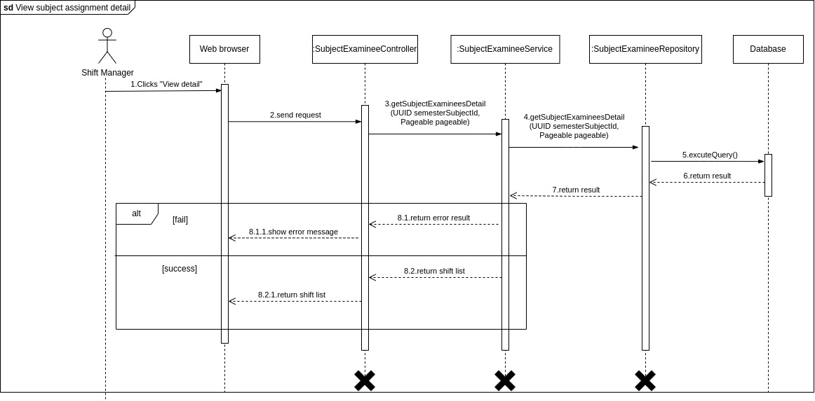

Figure . <Sequence Diagram> View subject assignments detail

#### 3.1.8. Manage exam room

##### Create exam room

Figure . <Sequence Diagram> Create exam room

##### Update exam room

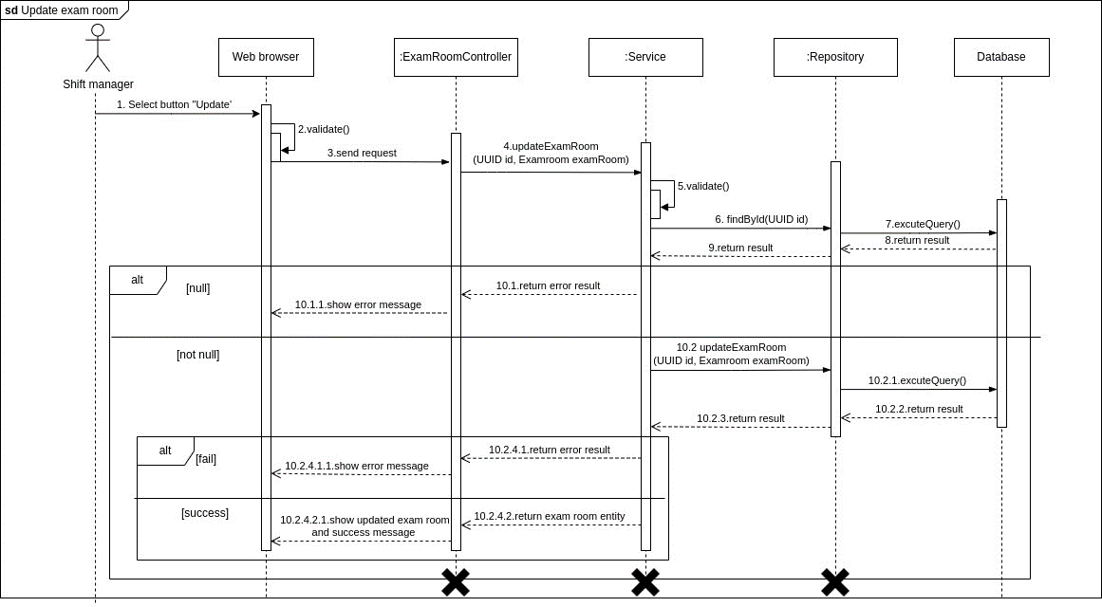

Figure . <Sequence Diagram> Update exam room

##### Remove exam room

Figure . <Sequence Diagram> Remove exam room

##### View exam shift list

Figure . <Sequence Diagram> View exam shift list

##### Create attendance

Figure . <Sequence Diagram> Create attendance

##### Delete attendance

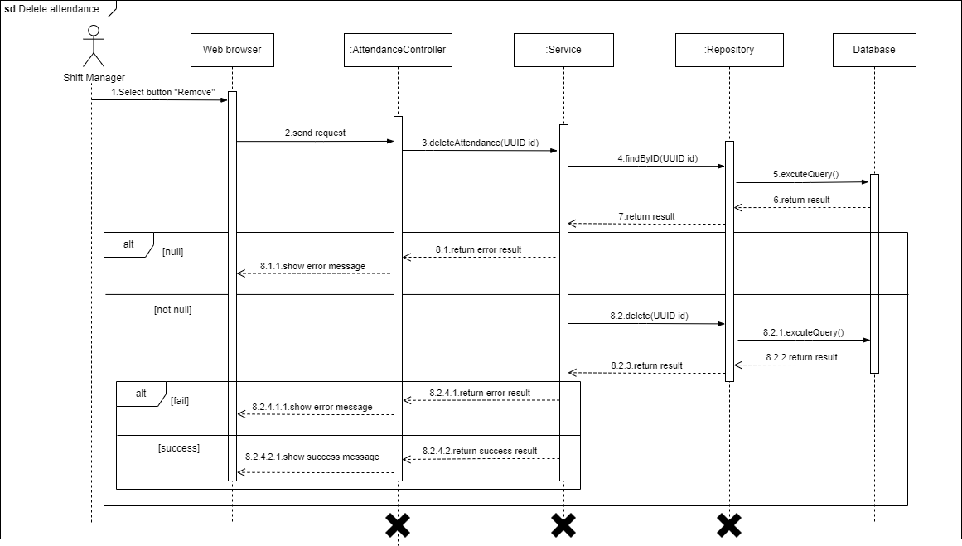

Figure . <Sequence Diagram> Delete attendance

##### Export attendance

Figure . <Sequence Diagram> Export attendance

##### Export locked shift

Figure 51. <Sequence Diagram> Export locked shift

##### Assign staff

Figure 52. <Sequence Diagram> Assign staff

##### Auto assign staff

Figure 53. <Sequence Diagram> Auto assign staff

#### 3.1.9. Login

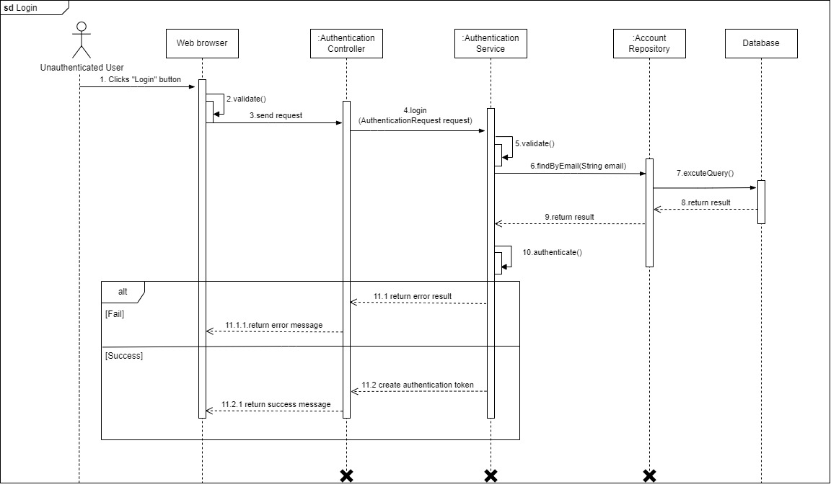

Figure . <Sequence Diagram> Login

#### 3.1.10. Logout

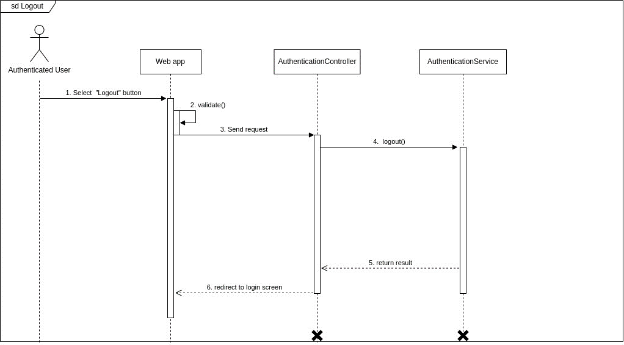

Figure . <Sequence Diagram> Logout

#### 3.1.11. Change password

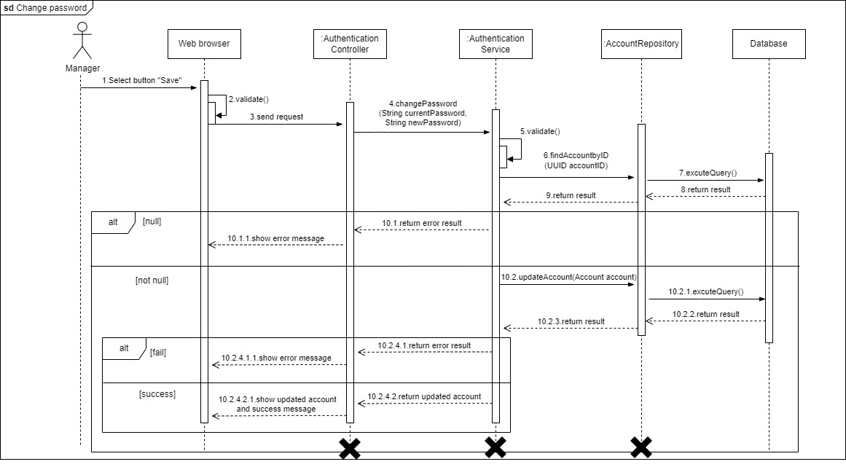

Figure . <Sequence Diagram> Change password

#### 3.1.12. View profile

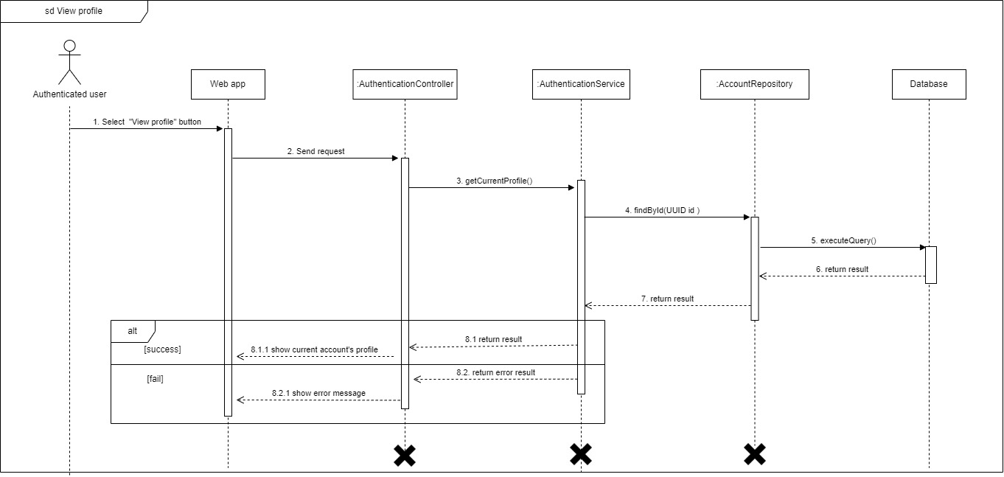

Figure . <Sequence Diagram> View profile

#### 3.1.13. Update profile

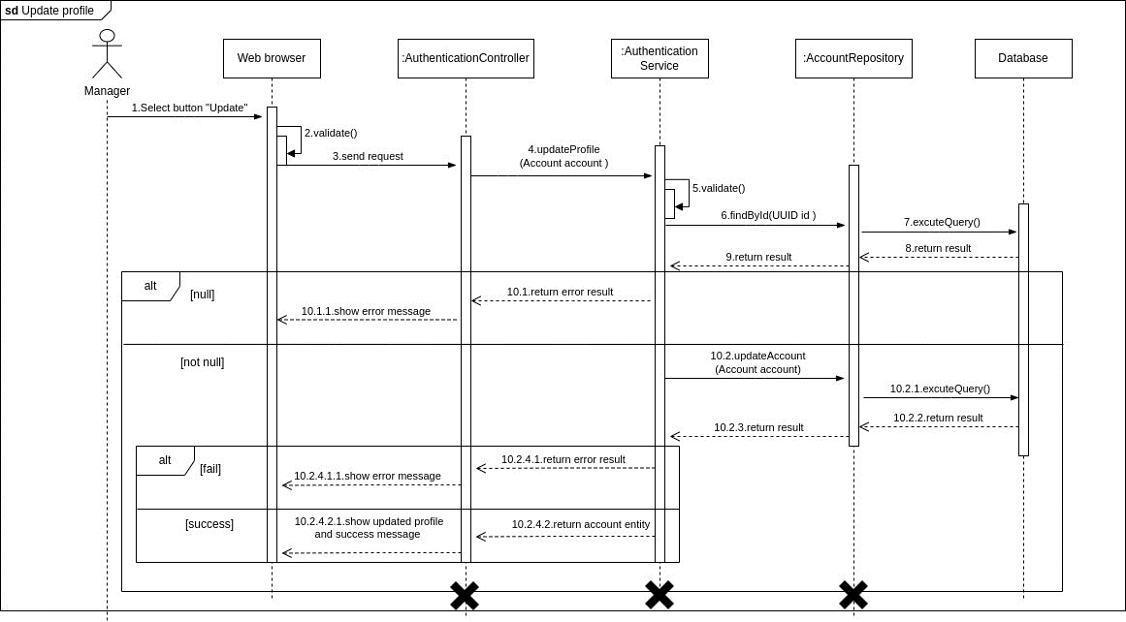

Figure . <Sequence Diagram> Update profile

#### 3.1.14. View notification list

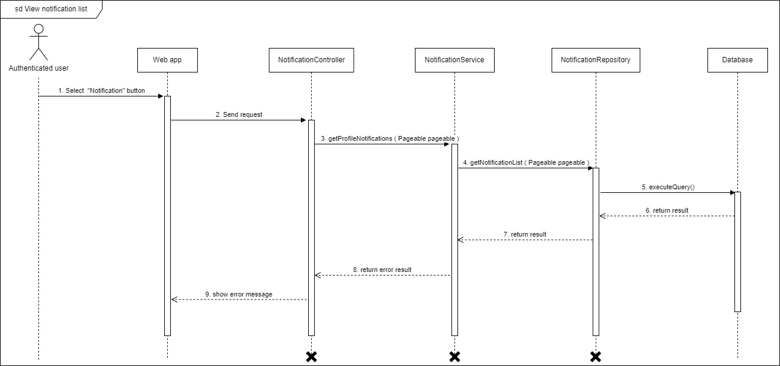

Figure . <Sequence Diagram> View notification list

#### 3.1.15. View report list

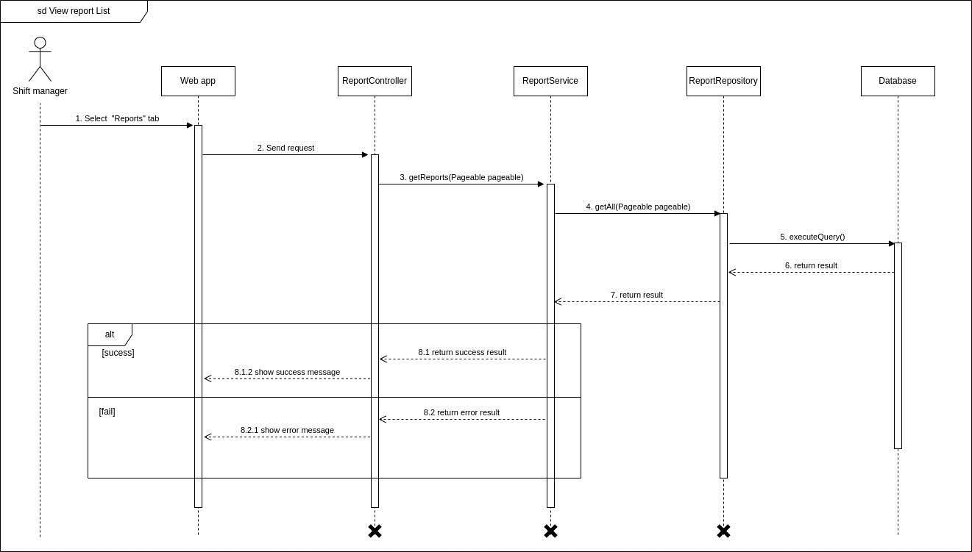

Figure . <Sequence Diagram> View report list

#### 3.1.16. View report detail

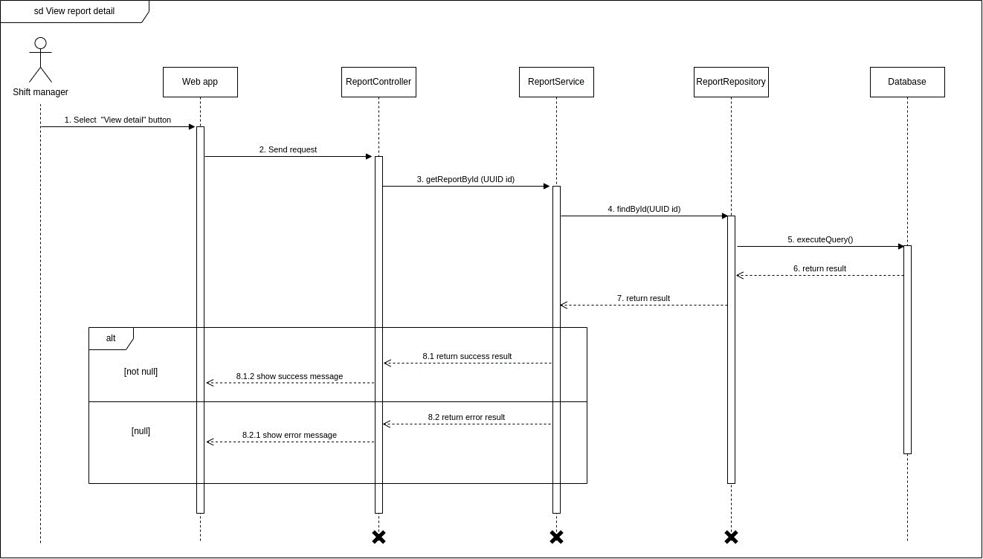

Figure . <Sequence Diagram> View report detail

#### 3.1.17. Resolve report

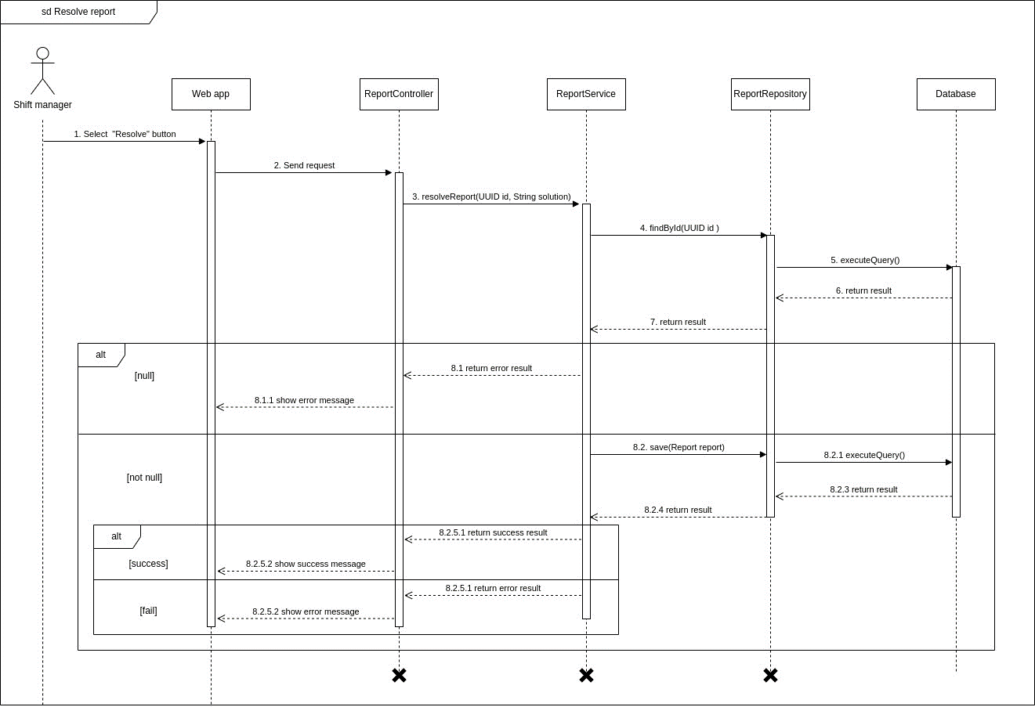

Figure . <Sequence Diagram> Resolve report

### 3.2 Activity Diagrams

#### 3.2.1. Update attendance

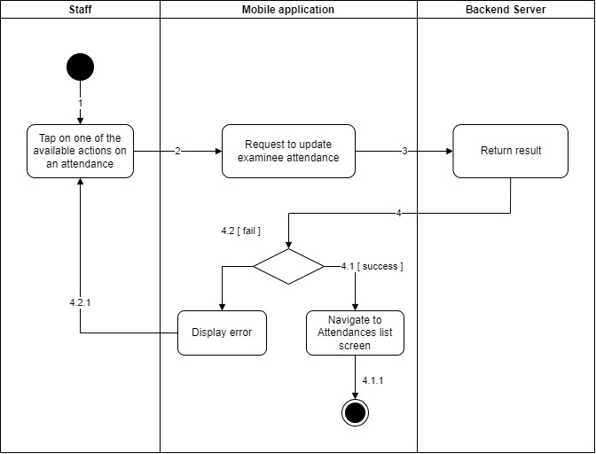

Figure . <Activity Diagram> Update attendance

#### 3.2.2. View attendances of exam room

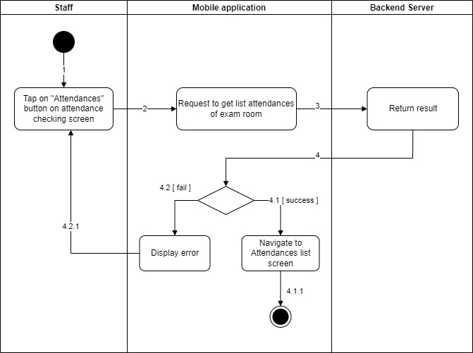

Figure . <Activity Diagram> View attendances of exam room

#### 3.2.3. Create report

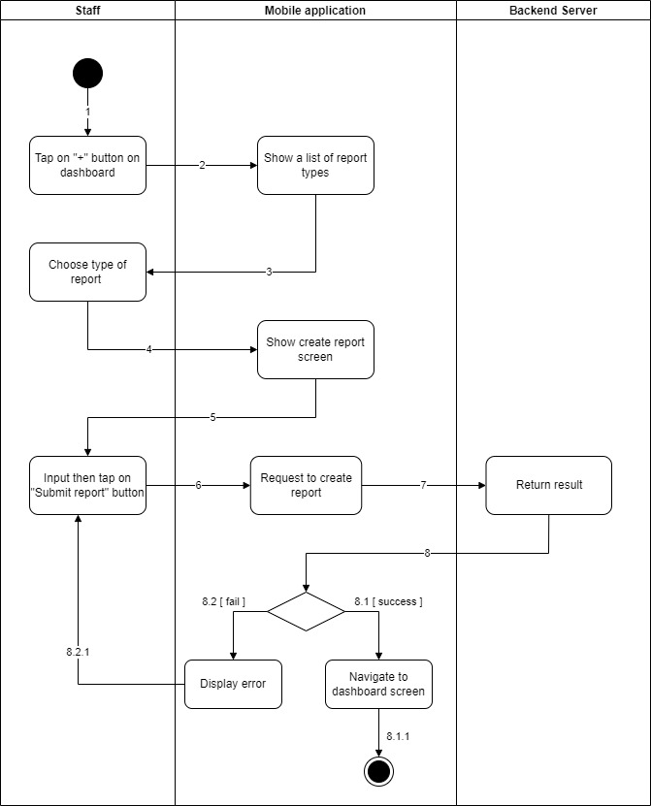

Figure . <Activity Diagram> Create report

#### 3.2.4. View assigned exam room

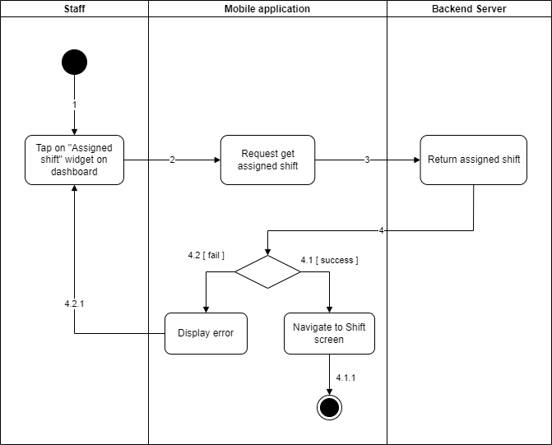

Figure . <Activity Diagram> View assigned exam room

#### 3.2.5. View assigned exam room report list

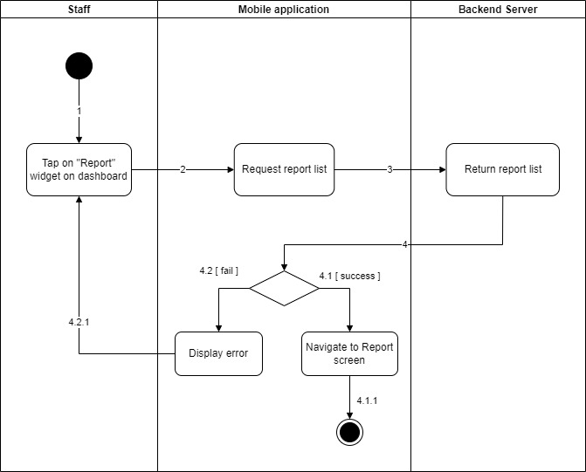

Figure . <Activity Diagram> View assigned exam room report list

#### 3.2.6. Update report

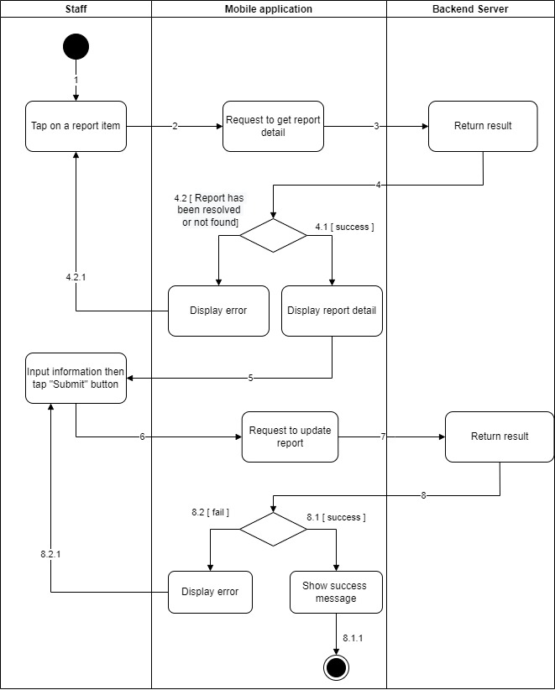

Figure . <Activity Diagram> Update report

#### 3.2.7. View own exam schedule

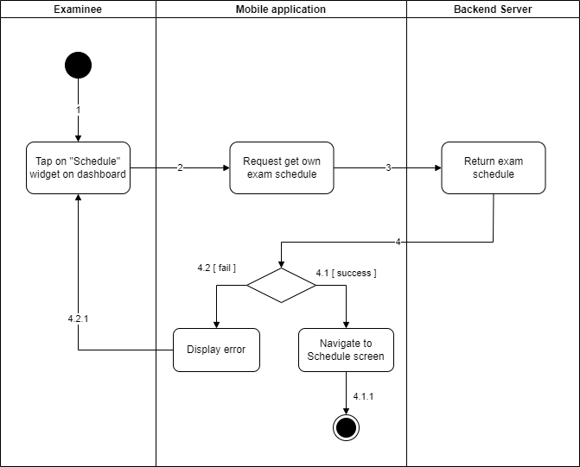

Figure . <Activity Diagram> View own exam schedule

#### 3.2.8. Check attendance

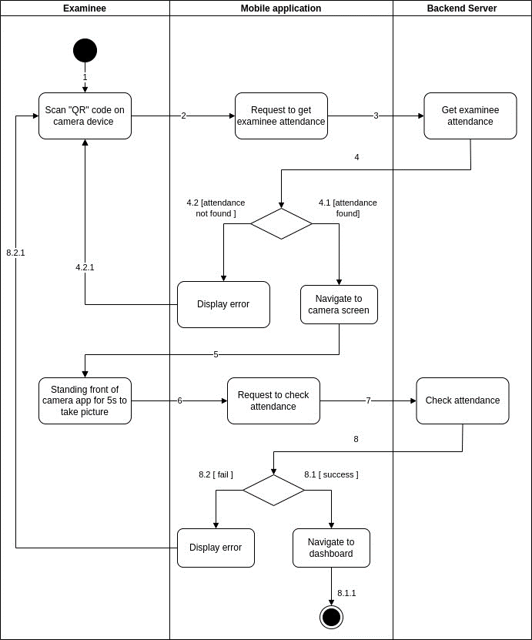

Figure . <Activity Diagram> Check attendance

### 3.3 State Diagrams

#### 3.3.1. Shift

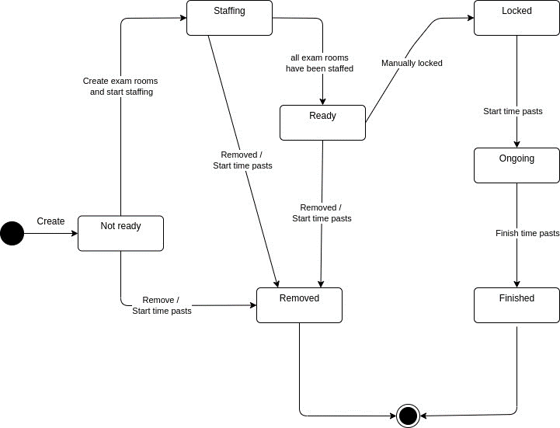

Figure . <State Diagram> Shift

#### 3.3.2. Exam room

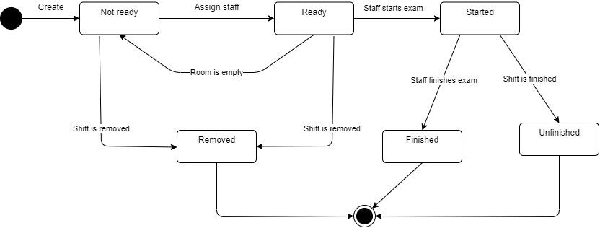

Figure . <State Diagram> Exam room

#### 3.3.3. Attendance

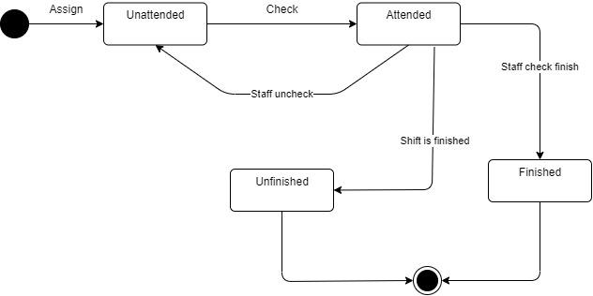

Figure . <State Diagram> Attendance

### 3.4 Class Diagrams

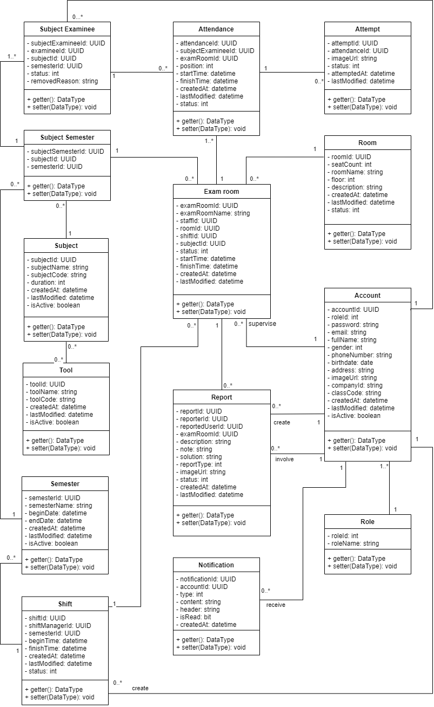

Figure . Class Diagram

## 4. Class Specifications

### 4.1. Account class

Table . <Class Specification> Account class

|  |  |  |
| --- | --- | --- |
| **Property** | **Type** | **Description** |
| accountId | UUID | Unique identifier of an account |
| roleId | int | Unique identifier of the user’s role |
| password | string | Password of the user |
| email | string | Email of the user |
| fullName | string | Full name of the user |
| gender | int | Gender of the user |
| phoneNumber | string | Phone number of the user |
| birthdate | date | Birthdate of the user |
| address | string | Address of the user |
| imageUrl | string | URL of the user’s profile picture |
| companyId | string | Company ID of the user |
| classCode | string | Class code of users with the “Examinee” role |
| createdAt | datetime | Created date of the user |
| lastModified | datetime | Last modified date of the user |
| isActive | boolean | Check if the account is available |
| getter() | data type | Get attribute of class |
| setter() | void | Set value of class’s attribute |

### 4.2. Role class

Table . <Class Specification> Role class

|  |  |  |
| --- | --- | --- |
| **Property** | **Type** | **Description** |
| roleId | UUID | Unique identifier of the user’s role |
| roleName | String | Name of the role |
| getter() | data type | Get attribute of class |
| setter() | void | Set value of class’s attribute |

### 4.3. Room class

Table . <Class Specification> Room class

|  |  |  |
| --- | --- | --- |
| **Property** | **Type** | **Description** |
| roomId | UUID | Unique identifier of the room |
| seatCount | int | The total seat count of a room |
| roomName | string | Name of the room |
| floor | int | The floor of the room |
| description | string | Description of the room |
| createdAt | datetime | Created date of the seat |
| lastModified | datetime | Last modified date of the seat |
| status | int | Status of the room |
| getter() | data type | Get attribute of class |
| setter() | void | Set value of class’s attribute |

### 4.4. Semester class

Table . <Class Specification> Semester class

|  |  |  |
| --- | --- | --- |
| **Property** | **Type** | **Description** |
| semesterId | UUID | Unique identifier of the semester |
| semesterName | string | Name of the semester |
| beginDate | datetime | Begin date of the semester |
| endDate | datetime | End date of the semester |
| isActive | boolean | Check if semester is available |
| getter() | data type | Get attribute of class |
| setter() | void | Set value of class’s attribute |

### 4.5. Shift class

Table . <Class Specification> Shift class

|  |  |  |
| --- | --- | --- |
| **Property** | **Type** | **Description** |
| shiftId | UUID | Unique identifier of the shift |
| shiftManagerId | UUID | Unique identifier of the shift’s manager |
| semesterId | UUID | Unique identifier of the shift’ semester |
| beginTime | datetime | Begin time of the shift |
| finishTime | datetime | Finish time of the shift |
| createdAt | datetime | Created date of the shift |
| lastModified | datetime | Last modified date of the shift |
| status | int | Status of the shift |
| getter() | data type | Get attribute of class |
| setter() | void | Set value of class’s attribute |

### 4.6. Subject class

Table . <Class Specification> Subject class

|  |  |  |
| --- | --- | --- |
| **Property** | **Type** | **Description** |
| subjectId | UUID | Unique identifier of the subject |
| subjectName | string | Name of the subject |
| subjectCode | string | Code of the subject |
| duration | int | The exam’s duration of the subject |
| createdAt | datetime | Created date of the subject |
| lastModified | datetime | Last modified date of the subject |
| isActive | boolean | Check if subject is available |
| getter() | data type | Get attribute of class |
| setter() | void | Set value of class’s attribute |

### 4.7. Notification class

Table . <Class Specification> Notification class

|  |  |  |
| --- | --- | --- |
| **Property** | **Type** | **Description** |
| notificationId | UUID | Unique identifier of notification |
| accountId | string | Unique identifier of receiver |
| type | int | Type of notification |
| content | string | Content of the notification in detail |
| header | string | Text that shows in notification item list |
| createdAt | datetime | Created date of the notification |
| lastModified | datetime | Last modified date of the notification |
| isRead | boolean | Check if this notification has been displayed |
| getter() | data type | Get attribute of class |
| setter() | void | Set value of class’s attribute |

### 4.8. Tool class

Table . <Class Specification> Tool class

|  |  |  |
| --- | --- | --- |
| **Property** | **Type** | **Description** |
| toolId | UUID | Unique identifier of tool |
| toolName | string | Name of tool |
| toolCode | string | Code of the tool |
| createdAt | datetime | Created date of the tool |
| lastModified | datetime | Last modified date of the tool |
| isActive | boolean | Check if tool is available |
| getter() | data type | Get attribute of class |
| setter() | void | Set value of class’s attribute |

### 4.9. Subject Semester class

Table . <Class Specification> Subject Semester class

|  |  |  |
| --- | --- | --- |
| **Property** | **Type** | **Description** |
| subjectSemesterId | UUID | Unique identifier of the subject semester |
| subjectId | UUID | Unique identifier of the subject semester’s subject |
| semesterId | UUID | Unique identifier of the subject semester’s semester |

### 4.10. Subject Examinee class

Table . <Class Specification> Subject Examinee Class

|  |  |  |
| --- | --- | --- |
| **Property** | **Type** | **Description** |
| subjectExamineeId | UUID | Unique identifier of the subject examinee |
| examineeId | UUID | Unique identifier of the subject examinees’s examinee |
| subjectId | UUID | Unique identifier of the subject examinee’s subject |
| semesterId | UUID | Unique identifier of the subject examinee’s semester |
| status | int | Status of subject examinee |
| removedReason | string | The reason of why the examinee was removed |
| getter() | data type | Get attribute of class |
| setter() | void | Set value of class’s attribute |

### 4.11. Attendance class

Table . <Class Specification> Attendance class

|  |  |  |
| --- | --- | --- |
| **Property** | **Type** | **Description** |
| attendanceId | UUID | Unique identifier of the attendance |
| subjectExamineeId | UUID | Unique identifier of the attendance’s subject examinee |
| examRoomId | UUID | Unique identifier of the attendance’s exam room |
| position | int | Exam seat of the attendance |
| startTime | datetime | The time when attendance check in the exam room |
| finishTime | datetime | The time when attendance finish the exam |
| createdAt | datetime | Created date of the attendance |
| lastModified | datetime | Last modified date of the attendance |
| status | int | Status of the attendance |
| getter() | data type | Get attribute of class |
| setter() | void | Set value of class’s attribute |

### 4.12. Exam room class

Table . <Class Specification> Exam room class

|  |  |  |
| --- | --- | --- |
| **Property** | **Type** | **Description** |
| examRoomId | UUID | Unique identifier of the exam room |
| examRoomName | string | Name of the exam room |
| staffId | UUID | Unique identifier of the exam room’s staff |
| roomId | UUID | Unique identifier of the exam room’s room |
| shiftId | UUID | Unique identifier of the exam room’s shift |
| subjectId | UUID | Unique identifier of the exam room’s subject |
| status | int | Exam room status |
| startTime | datetime | Start time of the exam room |
| finishTime | datetime | Finish time of the exam room |
| createdAt | datetime | Created date of the exam room |
| lastModified | datetime | Last modified date of the exam room |
| status | int | Status of the exam room |
| getter() | data type | Get attribute of class |
| setter() | void | Set value of class’s attribute |

### 4.13. Report class

Table . <Class Specification> Report class

|  |  |  |
| --- | --- | --- |
| **Property** | **Type** | **Description** |
| reportId | UUID | Unique identifier of the report |
| reporterId | UUID | Unique identifier of the reporter |
| reportedUserId | UUID | Unique identifier of the report’s reported user |
| examRoomId | UUID | Unique identifier of the report’s exam room |
| description | string | Description of the report |
| note | string | Extra note of the report |
| solution | string | Solution of the report resolved by shift manager |
| reportType | int | Type of the report |
| imageUrl | string | Attached image url of the report |
| status | int | Status of the report |
| createdAt | datetime | Created date of the report |
| lastModified | datetime | Last modified date of the report |
| getter() | data type | Get attribute of class |
| setter() | void | Set value of class’s attribute |

### 4.14. Attempt class

Table . <Class Specification> Attempt class

|  |  |  |
| --- | --- | --- |
| **Property** | **Type** | **Description** |
| attemptId | UUID | Unique identifier of the attempt |
| attendanceId | UUID | Unique identifier of the attempt’s attendance |
| imageUrl | UUID | Attached image url of the attempt |
| status | UUID | Status of the attempt |
| attemptedAt | string | The time when the attempted was taken |
| lastModified | string | Last modified date of the attempt |
| getter() | data type | Get attribute of class |
| setter() | void | Set value of class’s attribute |

## 5. Data & Database Design

### 5.1. Database Design

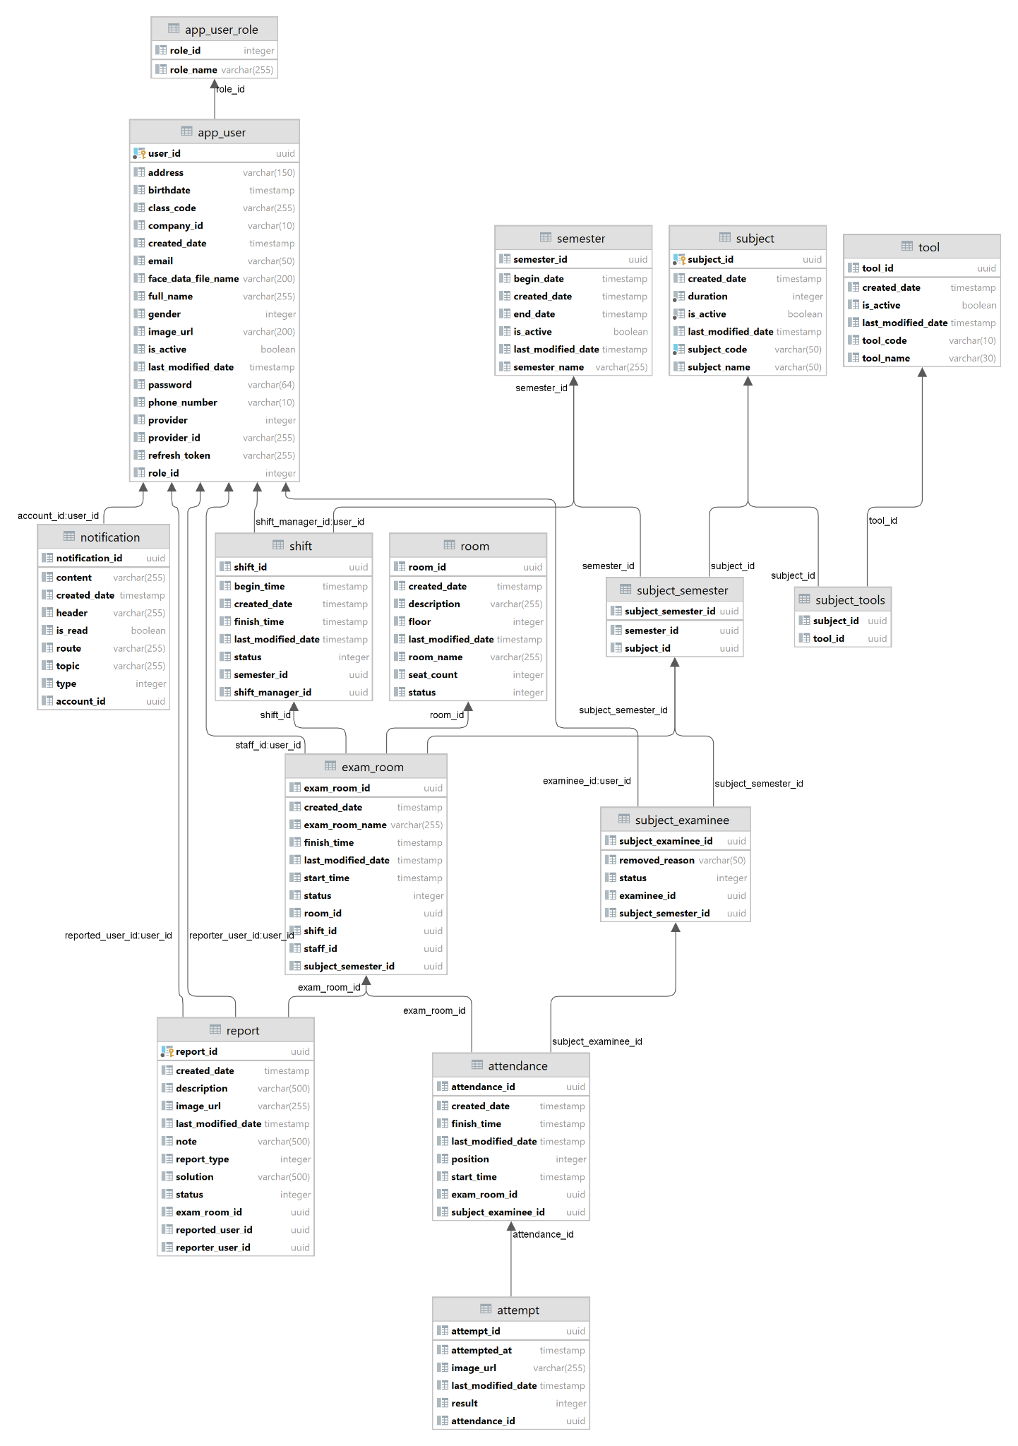

Figure . Database design

### 5.2. Data Dictionary

#### 5.2.1. App user table

Table . <Database Design> App user table

|  |  |  |  |  |  |  |
| --- | --- | --- | --- | --- | --- | --- |
| **Field name** | **Type** | **Size** | **Unique** | **Not Null** | **PK/FK** | **Notes** |
| user_id | uuid |  | Yes | Yes | PK | Unique identifier of the user |
| address | varchar | 150 | No | Yes |  | Address of the user |
| birthdate | timestamp |  | No | Yes |  | Birthdate of the user |
| class_code | varchar | 20 | No | No |  | Class code of a user with role of “Examinee” |
| company_id | varchar | 10 | Yes | Yes |  | Company ID of the user |
| created_date | timestamp |  | No | No |  | Created date of the user |
| email | varchar | 50 | Yes | Yes |  | Email address of the user |
| face_data_file_name | varchar | 200 | No | No |  | Face data file name of the user |
| full_name | varchar | 255 | No | Yes |  | Full name of the user |
| gender | int4 |  | No | Yes |  | Gender of the user (1 for male, 0 for female) |
| image_url | varchar | 200 | No | No |  | URL to the profile picture of the user |
| is_active | bool |  | No | Yes |  | Check if the user is available |
| last_modified_date | timestamp |  | No | No |  | Last modified date of the user |
| password | varchar | 64 | No | Yes |  | Encrypted password of the user |
| phone_number | varchar | 10 | Yes | No |  | Phone number of the user (for Vietnamese phone numbers) |
| provider | int4 |  | No | No |  | Identifier of the user’s OAuth2 provider |
| provider_id | varchar | 255 | No | No |  | Unique string identifier for this provider type |
| refresh_token | varchar | 255 | Yes | No |  | Refresh token of the user |
| role_id | int4 |  | No | No |  | Unique identifier of the user’s role |

#### 5.2.2. App user role table

Table . <Database Design> App user role table

|  |  |  |  |  |  |  |
| --- | --- | --- | --- | --- | --- | --- |
| **Field name** | **Type** | **Size** | **Unique** | **Not Null** | **PK/FK** | **Notes** |
| role_id | int4 |  | Yes | Yes | PK | Unique identifier of role |
| role_name | varchar | 256 | No | Yes |  | Name of role |

#### 5.2.3. Attempt table

Table . <Database Design> Attempt table

|  |  |  |  |  |  |  |
| --- | --- | --- | --- | --- | --- | --- |
| **Field name** | **Type** | **Size** | **Unique** | **Not Null** | **PK/FK** | **Notes** |
| attempt_id | uuid |  | Yes | Yes | PK | Unique identifier of the shift |
| attempt_at | timestamp |  | No | No |  | The time when the attempted was take |
| image_url | varchar | 255 | No | Yes |  | URL to the image url of the attempt |
| last_modified_date | timestamp |  | No | No |  | Last modified date of the attempt |
| result | int4 |  | No | No |  | Check if the attempt was successful or not |
| attendance_id | uuid |  | No | Yes | FK | Unique identifier of the attempt’s attendance |

#### 5.2.4. Attendance table

Table . <Database Design> Attendance table

|  |  |  |  |  |  |  |
| --- | --- | --- | --- | --- | --- | --- |
| **Field name** | **Type** | **Size** | **Unique** | **Not Null** | **PK/FK** | **Notes** |
| attendance_id | uuid |  | Yes | Yes | PK | Unique identifier of the attendance |
| created_date | timestamp |  | No | No |  | Created date of the attendance |
| finish_time | timestamp |  | No | No |  | The time when the attendance has been finished |
| last_modified_date | timestamp |  | No | No |  | Last modified date of the attendance |
| position | int4 |  | No | No |  | Exam seat of the attendance |
| start_time | timestamp |  | No | No |  | The time the attendance has been started |
| exam_room_id | uuid |  | No | No | FK | Unique identifier of the attendance’s exam room |
| subject_exaxminee_id | uuid |  | No | Yes | FK | Unique identifier of the attendance’s subject examinee |

#### 5.2.5. Exam room table

Table . <Database Design> Exam room table

|  |  |  |  |  |  |  |
| --- | --- | --- | --- | --- | --- | --- |
| **Field name** | **Type** | **Size** | **Unique** | **Not Null** | **PK/FK** | **Notes** |
| exam_room_id | uuid |  | Yes | Yes | PK | Unique identifier of the exam room |
| created_date | timestamp |  | No | No |  | Created date of the exam room |
| exam_room_name | varchar | 255 | No | Yes |  | Name of the exam room |
| finish_time | timestamp |  | No | No |  | Finish time of the exam room |
| last_modified_date | int4 |  | No | No |  | Last modified date of the exam room |
| start_time | timestamp |  | No | No |  | Start time of the exam room |
| status | int4 |  | No | Yes |  | Status of the exam room (Not ready, Ready, Started, Finished) |
| room_id | uuid |  | No | Yes | FK | Unique identifier of the exam room’s room |
| shift_id | uuid |  | No | Yes | FK | Unique identifier of the exam room’s shift |
| staff_id | uuid |  | No | No | FK | Unique identifier of the exam room’s staff |
| subject_semester_id | uuid |  | No | Yes | FK | Unique identifier of the exam room’s subject semester |

#### 5.2.6. Notification table

Table . <Database Design> Notification table

|  |  |  |  |  |  |  |
| --- | --- | --- | --- | --- | --- | --- |
| **Field name** | **Type** | **Size** | **Unique** | **Not Null** | **PK/FK** | **Notes** |
| notification_id | uuid |  | Yes | Yes | PK | Unique identifier of the notification |
| content | varchar | 255 | No | No |  | Content of the notification |
| created_date | timestamp | 255 | No | No |  | Created date of the notification |
| header | varchar | 255 | No | No |  | Header title of notification |
| is_read | bool |  | No | No |  | Check if notification has been read |
| route | varchar | 255 | No | No |  | Route to navigate to when notification is clicked |
| topic | varchar | 255 | No | No |  | The topic that users subscribe to receive notification |
| type | int4 |  | No | Yes |  | Type of notification |
| account_id | uuid |  | No | Yes | FK | Unique identifier of the notification’s account receiver |

#### 5.2.7. Report table

Table . <Database Design> Report table

|  |  |  |  |  |  |  |
| --- | --- | --- | --- | --- | --- | --- |
| **Field name** | **Type** | **Size** | **Unique** | **Not Null** | **PK/FK** | **Notes** |
| report_id | uuid |  | Yes | Yes | PK | Unique identifier of the report |
| created_date | timestamp |  | No | No |  | Created date of the report |
| description | varchar | 500 | No | Yes |  | Description of the report |
| image_url | varchar | 255 | No | No |  | Attached image url of the report |
| last_modified_date | timestamp |  | No | No |  | Last modified date of the report |
| note | varchar | 500 | No | No |  | Extra note of the report |
| report_type | int4 |  | No | Yes |  | Type of the report |
| solution | varchar | 500 | No | No |  | Solution of the report resolved by shift manager |
| status | int4 |  | No | Yes |  | Status of the report (Pending, Resolved) |
| exam_room_id | uuid |  | No | Yes | FK | Unique identifier of the report’s exam room |
| reported_user_id | uuid |  | No | No | FK | Unique identifier of the report’s reported user |
| reporter_user_id | uuid |  | No | Yes | FK | Unique identifier of the report’s reporter |

#### 5.2.8. Room table

Table . <Database Design> Room table

|  |  |  |  |  |  |  |
| --- | --- | --- | --- | --- | --- | --- |
| **Field name** | **Type** | **Size** | **Unique** | **Not Null** | **PK/FK** | **Notes** |
| room_id | uuid |  | Yes | Yes | PK | Unique identifier of the room |
| created_date | timestamp |  | No | No |  | Created date of the room |
| description | varchar | 255 | No | No |  | Description of the room |
| floor | int4 |  | No | No |  | Floor of the room |
| last_modified_date | timestamp |  | No | No |  | Last modified date of the room |
| room_name | varchar | 255 | Yes | No |  | Name of the room |
| seat_count | int4 |  | No | No |  | The total seat count of a room |
| status | int4 |  | No | Yes |  | Status of the room (Available and Unavailable) |

#### 5.2.9. Semester table

Table . <Database Design> Semester table

|  |  |  |  |  |  |  |
| --- | --- | --- | --- | --- | --- | --- |
| **Field name** | **Type** | **Size** | **Unique** | **Not Null** | **PK/FK** | **Notes** |
| semester_id | uuid |  | Yes | Yes | PK | Unique identifier of the semester |
| begin_date | timestamp |  | No | No |  | Begin date of the semester |
| created_date | timestamp |  | No | No |  | Created date of the semester |
| end_date | timestamp |  | No | No |  | End date of the semester |
| is_active | bool |  | No | Yes |  | Check if semester is available |
| last_modified_date | timestamp |  | No | No |  | Last modified date of the semester |
| semester_name | varchar | 255 | Yes | Yes |  | Name of the semester |

#### 5.2.10. Shift table

Table . <Database Design> Shift table

|  |  |  |  |  |  |  |
| --- | --- | --- | --- | --- | --- | --- |
| **Field name** | **Type** | **Size** | **Unique** | **Not Null** | **PK/FK** | **Notes** |
| shift_id | uuid |  | Yes | Yes | PK | Unique identifier of the shift |
| begin_time | timestamp |  | No | No |  | Begin time of the shift |
| created_date | timestamp |  | No | No |  | Created date of the shift |
| finish_time | timestamp |  | No | No |  | Finish time of the shift |
| last_modified_date | timestamp |  | No | No |  | Last modified date of the shift |
| status | int4 |  | No | Yes |  | Status of the shift (Removed, Finished, Locked, Ready, Not-ready, Staffing, Ongoing) |
| semester_id | uuid |  | No | Yes | FK | Unique identifier of the shift’s semester |
| shift_manager_id | uuid |  | No | Yes | FK | Unique identifier of the shift’s shift manager |

#### 5.2.11. Subject table

Table . <Database Design> Subject table

|  |  |  |  |  |  |  |
| --- | --- | --- | --- | --- | --- | --- |
| **Field name** | **Type** | **Size** | **Unique** | **Not Null** | **PK/FK** | **Notes** |
| subject_id | uuid |  | Yes | Yes | PK | Unique identifier of the subject |
| created_date | timestamp |  | No | No |  | Created date of the subject |
| duration | int4 |  | No | Yes |  | The exam’s duration of the subject |
| is_active | bool |  | No | Yes |  | Check if subject is available |
| last_modified_date | timestamp |  | No | No |  | Last modified date of the subject |
| subject_code | varchar | 50 | Yes | Yes |  | Code of the subject |
| subject_name | varchar | 50 | Yes | Yes |  | Name of the subject |

#### 5.2.12. Subject examinee table

Table . <Database Design> Subject examinee table

|  |  |  |  |  |  |  |
| --- | --- | --- | --- | --- | --- | --- |
| **Field name** | **Type** | **Size** | **Unique** | **Not Null** | **PK/FK** | **Notes** |
| subject_examinee_id | uuid |  | Yes | Yes | PK | Unique identifier of the subject examinee |
| removed_reason | varchar | 50 | No | Yes |  | The reason why the examinee was removed |
| status | int4 |  | No | Yes |  | Status of subject examinee (Assigned, Unassigned, Exempted) |
| examinee_id | uuid |  | No | Yes | FK | Unique identifier of the examinee |
| subject_semester_id | uuid |  | No | Yes | FK | Unique identifier of the subject examinee’s subject semester |

#### 5.2.13. Subject semester table

Table . <Database Design> Subject semester table

|  |  |  |  |  |  |  |
| --- | --- | --- | --- | --- | --- | --- |
| **Field name** | **Type** | **Size** | **Unique** | **Not Null** | **PK/FK** | **Notes** |
| subject_semester_id | uuid |  | Yes | Yes | PK | Unique identifier of the subject semester |
| semester_id | uuid |  | No | Yes | FK | Unique identifier of the subject semester’s semester |
| subject_id | uuid |  | No | Yes | FK | Unique identifier of the subject semester’s subject |

#### 5.2.14. Subject tool table

Table . <Database Design> Subject tool table

|  |  |  |  |  |  |  |
| --- | --- | --- | --- | --- | --- | --- |
| **Field name** | **Type** | **Size** | **Unique** | **Not Null** | **PK/FK** | **Notes** |
| subject_id | uuid |  | Yes | Yes | PK | Unique identifier of the subject |
| tool_id | uuid |  | No | Yes | FK | Unique identifier of the tool |

#### 5.2.15. Tool table

Table . <Database Design> Tool table

|  |  |  |  |  |  |  |
| --- | --- | --- | --- | --- | --- | --- |
| **Field name** | **Type** | **Size** | **Unique** | **Not Null** | **PK/FK** | **Notes** |
| tool_id | uuid |  | Yes | Yes | PK | Unique identifier of the tool |
| created_date | timestamp |  | No | No |  | Created date of the tool |
| is_active | bool |  | No | Yes |  | Check if tool is available |
| last_modified_date | timestamp |  | No | No |  | Last modified date of the tool |
| tool_code | varchar | 10 | Yes | Yes |  | Code of the tool |
| tool_name | varchar | 30 | Yes | Yes |  | Name of the tool |